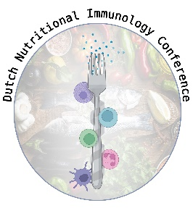

Dutch Nutritional Immunology Conference
‘Feeding connections’
April 16th, 2026
Utrecht

DNIC26 ABSTRACT FORM
Please do not change font, font size, and formatting

Title
-insert title here-

Author¹, Author² (Please underline presenting author)

¹Affiliation 1
²Affiliation 2
Introduction:
Methods:
Results:
Conclusions:

Please indicate abstract topic: Intestinal Immunology / (Chronic) Inflammation/ Allergy /Immune Resilience & Infection

Title: Maximum 110 characters
Abstract text: Maximum 300 words
Please use the text settings and formatting of this abstract
Abstract deadline : Monday 2nd of March 2026
Communication of acceptance before Friday 20th of March 2026

