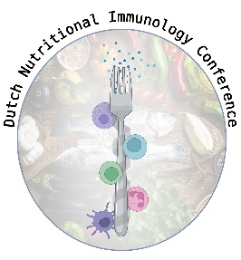

Dutch Nutritional Immunology Conference

‘Feeding connections’

April 24th 2025

Wageningen

**Registration form**

Name:………………………………………………………………………………………………………………………………..

Affiliation: ………………………………………………………………………………………………………………………….

Email: ………………………………………………………………………………………………………………………………..

Dietary wishes : …………………………………………………………………………………………………………………

Remarks: …………………………………………………………………………………………………………………………..

To register please email this form to [DNIC.nutritionalimmunology@gmail.com](mailto:DNIC.nutritionalimmunology@gmail.com)

Abstract submission is optional but encouraged ! The abstract deadline is February 28

When registering, please transfer the registration fee of 25 Euro with reference to ASG/CBI Dutch Nutritional Immunology Meeting in the payment subject. Please note that for practical reasons a refund is not possible after registration, we hope you understand.

Wageningen University

IBAN Account number: NL61ABNA0539509388

BIC/SWIFT code ABNANL2A