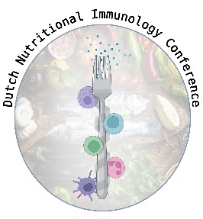

Dutch Nutritional Immunology Conference

‘Feeding connections’

April 24th 2025

Wageningen

**DNIC25 ABSTRACT FORM**

**Please do not change font, font size, and formatting**

**Title**

Author1, Author2 (Please underline presenting author)

1Affiliation 1

2Affiliation 2

*Introduction:* text

*Aim:* text

*Methods:* text

*Results:* text

*Conclusions:* text

Please indicate abstract topic: Infection / Chronic Inflammation/ Allergy /Autoimmunity / Other

Title: Maximum 110 characters

Abstract text: Maximum 1750 characters (approximately 350 words)

Please use the text settings and formatting of this abstract

**Abstract deadline : Friday February 28 at 23.59**

**Communication of acceptance before Tuesday April 8**